Jump Canada Hall of Fame Ponies

2011 – Three’s A Crowd
Owner: Corie Bannister, Schomberg
2008 and 2009 RAWF Small Pony Champion
The current Small Pony Championship at the RAWF is in her name

2010 – No pony awarded

2009 – *Farnley Melanie
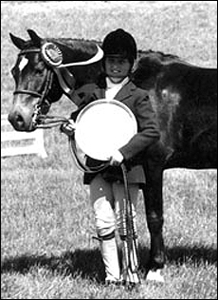
1980 – 2004 bay USA-bred Welsh A mare (Farnley Sunshadow X *Coed Coch Nerys)
Breeder: Farnley Farms, White Plains VA
Purchased by the Tattersall family as a weanling Melanie won many Championships on the line in first 2 years before going in Small Pony Hunter divisions. As a 3 year old was 4th in the province in Small Pony Hunter. Melanie was Overall Pony Hunter Champion at Canadian Pony Breeders in 1988 with Jackie Tattersall.
Melanie then went with Jay Hayes, Tattersall’s coach, to Arizona for Hayes’ daughter Lauren, where they were Reserve Circuit Champion. Melanie also won the Open Hunter Classic at the Tournament of Champions with a final score of 80, which was unbeatable by the 3’ and 3’6” Hunters.
Melanie was returned to the Tattersalls to produce 6 foals (all with the Absolute prefix). She then returned to the ring with rider Devon Dander and won at the RAWF. Melanie was official retired in 2002.

2008 – Minnie Mouse
See profile as Canadian Pony Breeders Hall of Fame Inductee 1992

2007 – Wotten Nell
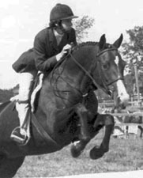
1966 - ? Welsh B X Thoroughbred (Ankerwyck Victor X Farielle)
Breeder: Doodie Stirling
1974 and 1975 National Champion Conformation and Large Pony
1983 H. Crang Memorial Trophy winner at RAWF

2006 – *Farnley Soya
1969 - 2006
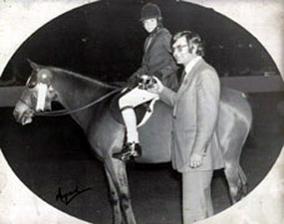
Bay mare
Breeder: Farnley Farms, Charlottesville VA

*Farnley Soya’s career spanned 2 decades and won a record number of Championship titles at the RAWF.
She was purchased as a 5 year old by Sue Pritchard for client Susan Biggar. “Beanic” won the RAWF that year. She was sold to Belinda Chopping and John Weir, later changed to Amber Castleman & Looking Back Farm. Her final trainer was Bobbie Reber and she showed under owners such as Chris Delia, Bonnie Lynn Fraser and Bobbie’s daughter.
Her final Championship was won at age 21. She was then sent to Pru Richardson’s to be bred to *Llanarth Senator producing 2 foals at age 24 & 25. With both her foals she was shipped to BC and died at age 37.

